**The unambiguous NL-SfB table 1.**

* Published on 26 January 2022
* [**Edit article**](https://www.linkedin.com/post/edit/6886972887102734336/)
* [**View statistics**](https://www.linkedin.com/analytics/post-summary/urn:li:activity:6892017571172798464/)

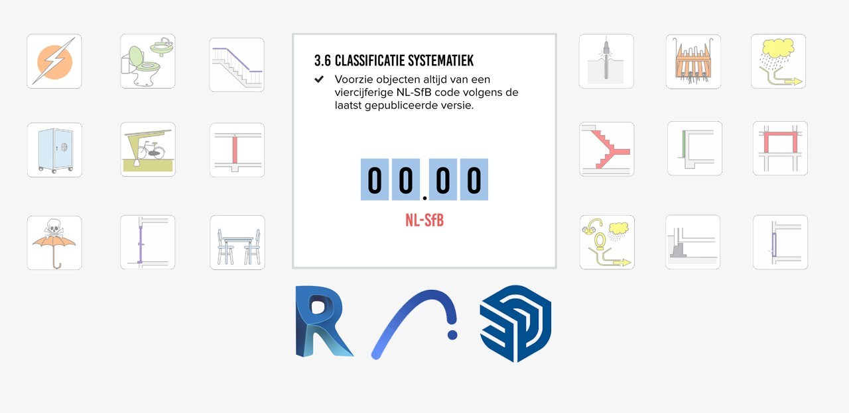

[[](https://www.linkedin.com/in/menno-mekes-a59829ba/)](https://www.linkedin.com/in/menno-mekes-a59829ba/)

[Status is online](https://www.linkedin.com/in/menno-mekes-a59829ba/)

**[Menno Mekes](https://www.linkedin.com/in/menno-mekes-a59829ba/)**

BIM specialist [Arons and Gelauff architects]

[14 items](https://www.linkedin.com/in/menno-mekes-a59829ba/recent-activity/posts/)

**What do you mean? We have been working with the latest update since December 2019, haven't we?**

Yes, you thought so. Me too though. Until I was on the other side of the model.

This article is quite long and gets more and more technical the further you read. As you are used to from me. In any case, read up to and including the download link. Then you know enough about the how and why.

I have created a very nice series of BIMcollab ZOOM (BCZ) Smart Views and Lists with which we can check our own models before we send them. The beauty of BCZ is its simplicity. The Ifc is read and displayed. Anyone can use the free version. And with that, filter the model in all desired ways. What is not possible is to create classifications as can be done in Solibri. There, different properties that should actually be called the same can be lumped together. It looks like this:

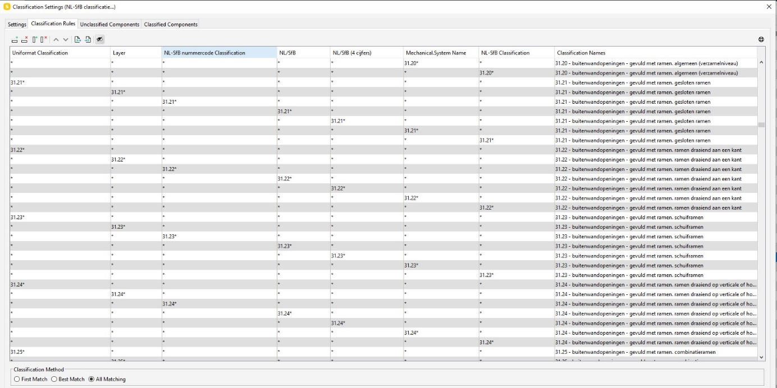

Each column contains a name of a classification. Without additional settings, the Assembly Code in Revit is exported to Uniformat. The name then becomes Uniformat Classification'. We have NL-SfB, NL/SfB, NL-SfB table 1, NL/SfB (4 digits), NL/SfB (4 digits) and so on. If a new model is loaded in Solibri, there is a good chance that you will have to adjust this classification. The last column states what it should actually be called. The names in the first columns are baked into the Ifc. It is a so-called IfcClassificationReference. A special, and particularly versatile, entity within the Ifc scheme.

This is what the bim directors do. Working with what they are offered. Some go further and prefer to edit the ifcs rather than tackle it at the source. Just look at the '[**Solibri Classification tool**](https://www.linkedin.com/posts/daanarts_ifc-ifc-activity-6879092349222432768-0AMv)' that [**Daan Arts**](https://www.linkedin.com/in/daanarts/) shows. It dissolves at the back. The same goes for the IfcElementAssemblies which have already been talked about a lot here. [**Juun Steen**](https://www.linkedin.com/in/juun-steen-b33a8b4/) has developed a [**Tool**](https://www.root-bv.nl/kennisbank/kennisbank-20-revit-archicad) that I have tested extensively and that our contractors are very happy with. So that road is not wrong. Very good even. But some things are really better to solve at the source.

* When the same things are called the same thing, everyone can find them.
* When the same things with the same name have the same content, they are really the same.

**But we still comply with BIM base IDM tile 3.6?**

**In principle, yes.**  If your code and description is correct, you comply. Because tile 3.6 is part of chapter 3. And it's about each aspect model individually.

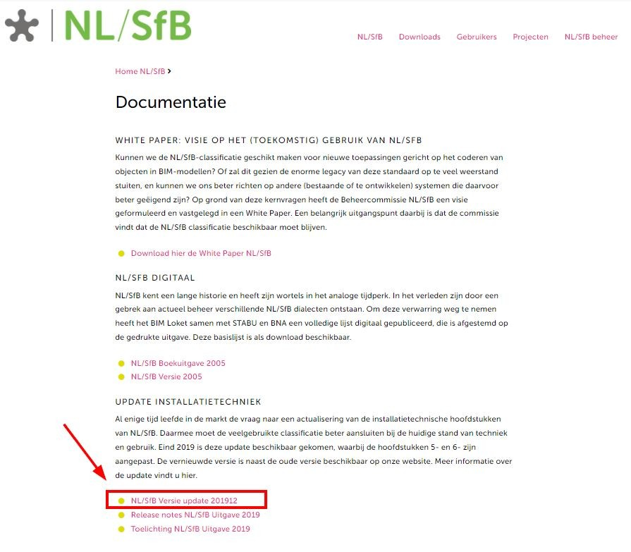

**In principle, no.**  Because we refer to the NL-SfB table 1 and it is [**here on BIM Loket**](https://stprodeuwmystabu002stor.blob.core.windows.net/overig/NL-SfB_Tabel_0-4_Update-V201912.xlsx) (Dutch organisation that collects, maintains and spread the BIM documents, standards etc.) and has been drawn up by Ketenstandaard. (The organisation that owns the NL-SfB Classification) In December 2019, chapters 5 and 6 were significantly modified. That's great for the installation world. But also for us structural engineers because now we can use 61.15. All the lists I have come across are not an exact match with this list.

I especially came across the 2005 list. After the update, the owners of the NL-SfB lists for the various software did not pick this up or did not pick it up properly. Lists that do have the 2019 update in them contain errors, incompleteness but above all: the exact description, column F of the table, has not been copied exactly. So we filter with the correct name of the classification but with the wrong content we still have 2 different lines in our viewer.

**In principle, no.**Because we promise to speak a common language. And we do that but in our own dialect. That dialect is spoken by the various modeling software. And that is why we exchange information by means of the Ifc scheme. And not through the source files. And so everything has to be translated correctly according to the agreements we make.

**Menno, if you complain you always have a solution ready, right?**

Definitely! If you work with Sketchup, Revit or Archicad at least.

With this software we are now modelling [**Wisselspoor field 6, 9 and 10 in Utrecht**](https://www.linkedin.com/posts/eklinkenberg_were-pleased-to-announce-that-developer-activity-6871741324601651200-qrn1). [**Office Winhov**](https://www.linkedin.com/company/office-winhov/) and [**Beta**](https://www.linkedin.com/company/beta-office/?originalSubdomain=nl) work in Archicad. [**Goudstikker de Vries**](https://www.linkedin.com/company/goudstikker-de-vries-b.v./) models the construction in Revit. [**Arons and Gelauff**](https://www.linkedin.com/company/aronsengelauff/) works in a hybrid form of Revit and Sketchup. I take care of the BIM coordination. Our client, [**Synchroon**](https://www.linkedin.com/company/synchroon-b-v-/), would also like to look into the models. That is why I have limited myself to these three for the time being.

**The NL-SfB lists can be found** [**here**](https://github.com/MennoMekes/NL-SfB-tabel-1-Classification).

Let's dive deeper into the matter. You can stop reading here. Or scroll to the software you use.

For Sketchup and Archicad, the .xml files are both structured slightly differently. Revit has a .txt file that is easy to load to fill in the Assembly Code. In addition to the content, the name of the classification must be correct. In the BIM base IDM tile 3.6 we recommend using the name 'NL-SfB tabel 1'. We are talking about the text that becomes visible in your favorite viewer. The name of the IfcClassificationReference. In SketchUP, that's no problem at all. The name you give is the name it becomes. In Archicad, the name will be given a suffix of the version. In Revit, a suffix 'Classification' is added. This is baked in the exporter and I can not remove or change it. If you can: call me! (Yes Sol and Jacob….you’ve got the power and connections to fix this)

For this reason, the classifications are called 'NL-SfB tabel 1 Classification'. This is (for now / for me) the only way to lump all the IfcClassificationReferences of the NL-SfB together and make everyone's life easier.

**REVIT**

For those who prefer to fill in the NL-SfB as an instance parameter, want to link in nested Families or want to secure the classification in a formula, I can use my Dynamo graphs. In [**this article**](https://www.linkedin.com/pulse/ik-ben-helemaal-klaar-met-de-assembly-code-menno-mekes/?src=aff-lilpar&veh=aff_src.aff-lilpar_c.partners_pkw.121977_plc.digidip%20GmbH_pcrid.510731_learning&trk=aff_src.aff-lilpar_c.partners_pkw.121977_plc.digidip%20GmbH_pcrid.510731_learning&clickid=0DIUd1yVFxyORHlwUx0Mo3EUUkG3M201n1sazQ0&mcid=6851962469594763264&irgwc=1) I explain that. The graphs are now suitable for Revit 2022 / Dynamo 2.12. You can find them [**here**](https://github.com/MennoMekes/Classification-Codes).

Most of you prefer to just click through the Assembly Code. Also very good. Make sure you set the export settings correctly. Fill in the Name correctly: **NL-SfB tabel 1**. At Classification field name you enter **Assembly Code**. Now the IfcClassificationReference is called: **NL-SfB tabel 1 Classification** in the Ifc export. (Instead of Uniformat Classification.)

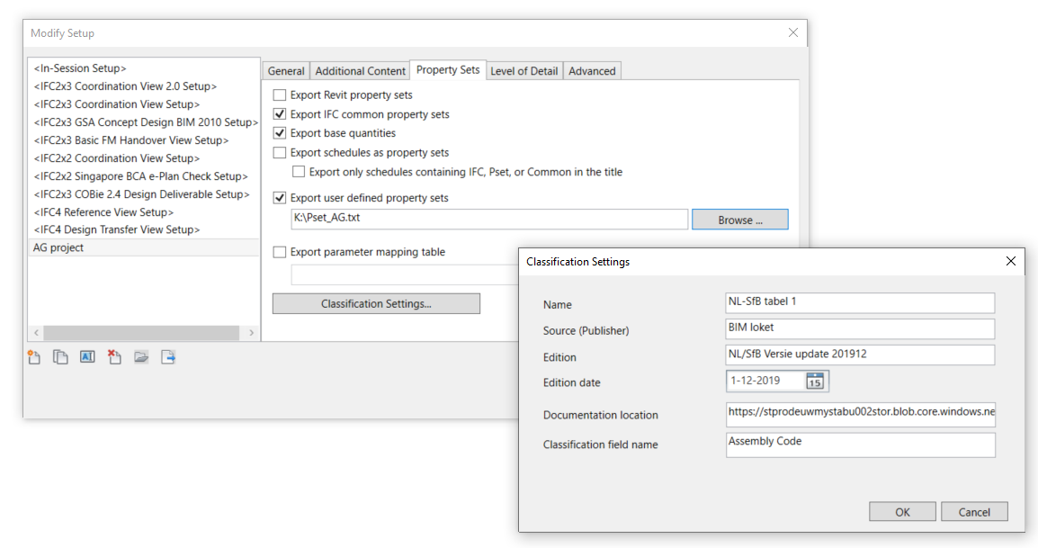

Here you can find the list: [**https://github.com/MennoMekes/NL-SfB-tabel-1-Classification/tree/Revit**](https://github.com/MennoMekes/NL-SfB-tabel-1-Classification/tree/Revit). Click the arrow next to Code on the green button and then Download ZIP.

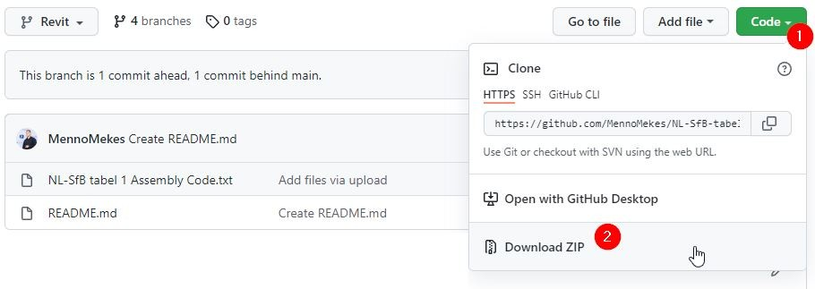

Setting up is easy. You probably already know it.

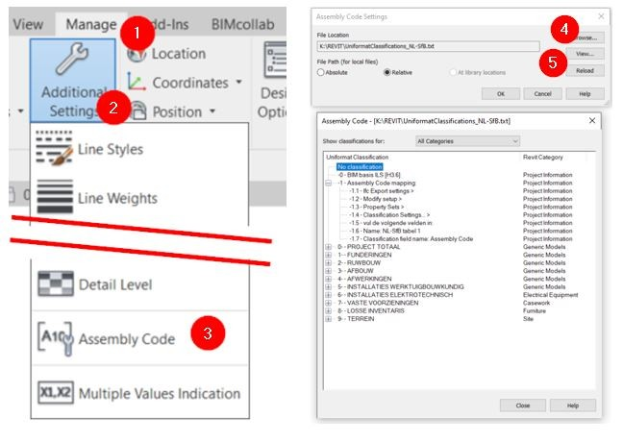

1. Manage
2. Additional Settings
3. Assembly Code
4. Browse
5. View to view the file if you want.

That's all you have to do. A small effort, right?

**ARCHICAD**

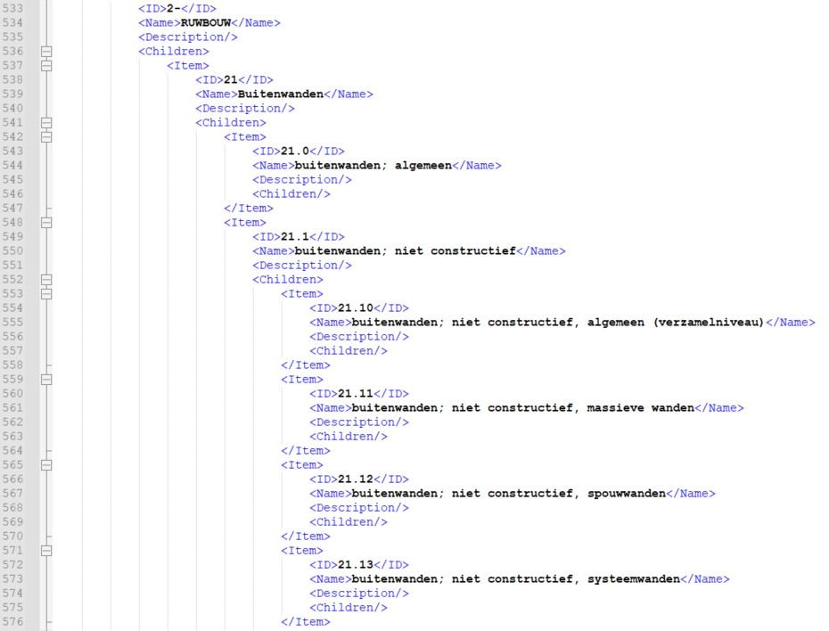

In Archicad you can load as many classifications as you want. This is very useful if you also want to use other encodings in addition to the NL-SfB.

These files are structured in a certain way. Here on the right you see part of the .xml file. Pretty clear, right?

Here you can find the list: [**https://github.com/MennoMekes/NL-SfB-tabel-1-Classification/tree/Archicad**](https://github.com/MennoMekes/NL-SfB-tabel-1-Classification/tree/Archicad). Click the arrow next to Code on the green button and then Download ZIP.

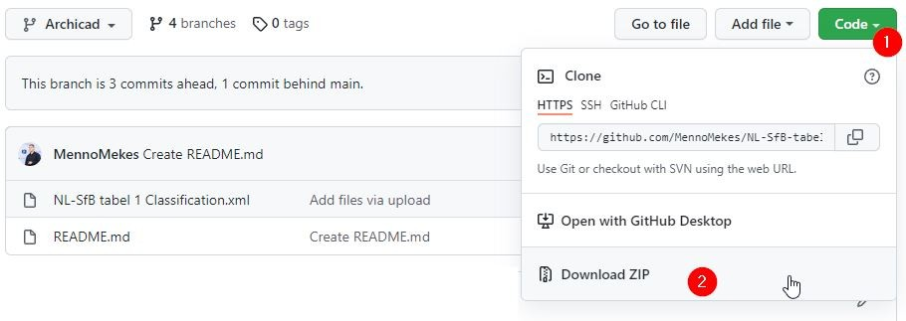

To load the correct list, first go to the Classification Manager. This is in the IFC toolbar or you go to the pull-down menu 'Options'. At the bottom, click on import:

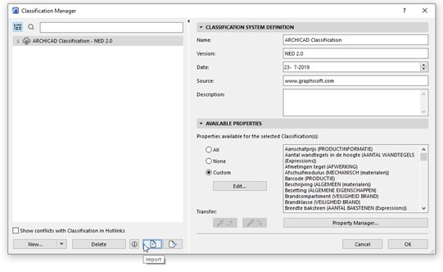

And load the file:

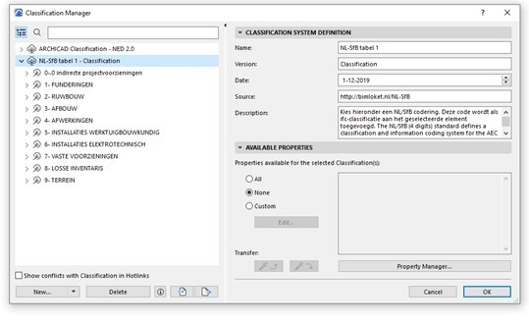

What you see with the Classification system definition is that the name is 'NL-SfB tabel 1'. Below that is the version. instead of a date or number, it says 'Classification'. This is, as explained earlier, a way to keep all the names of the classifications exactly the same. In Archicad you can now provide the elements with the correct NL-SfB coding + name in the usual way:

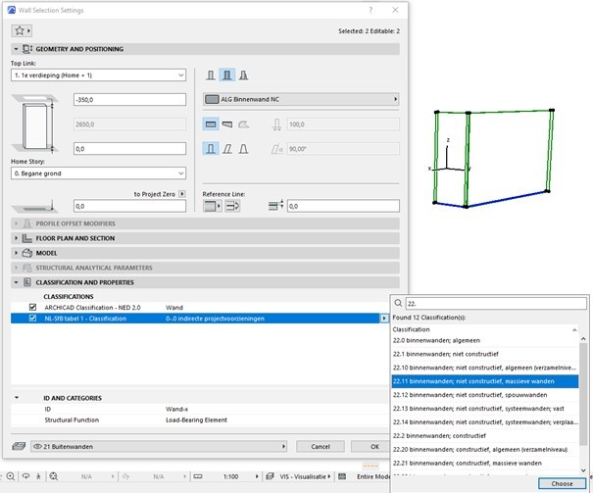

**SKETCHUP**

In Sketchup you use the ifc manager to build the model neatly according to the Ifc schema. You can find out how to do that in [**this guide**](https://www.bimloket.nl/documents/Handleiding_SketchUp_BIM_basis_ILS_2_0.pdf).

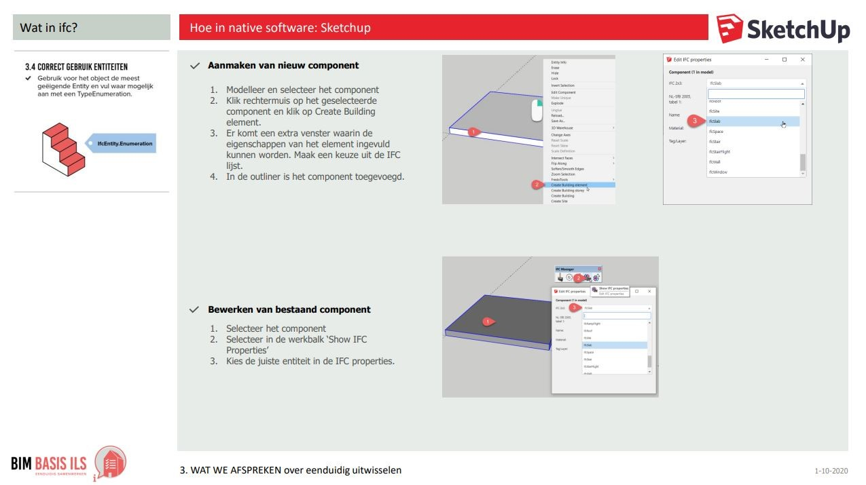

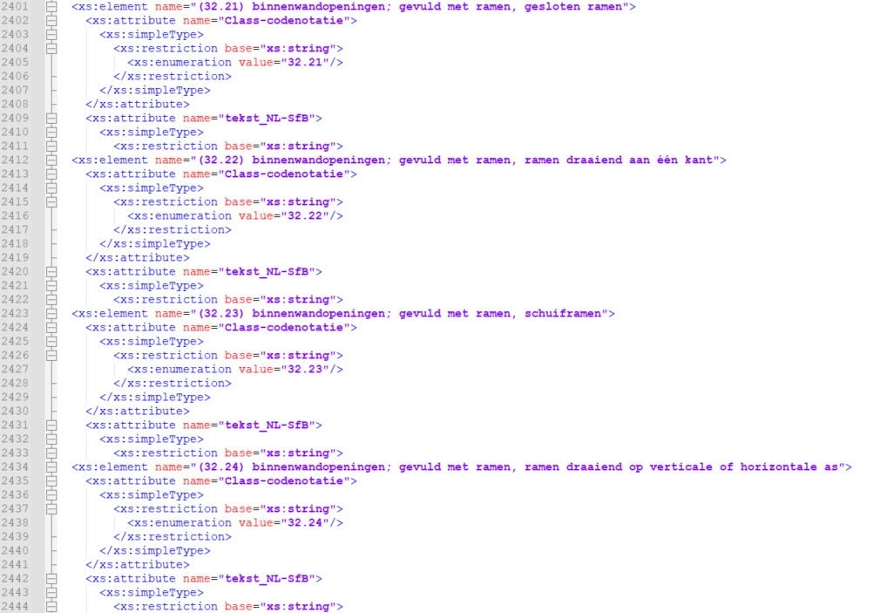

In the dialog box where you can choose the right entity there is a second pull-down for the NL-SfB. In the current version ([**3.4.7**](https://github.com/BIM-Tools/SketchUp-IFC-Manager/releases/tag/v.3.4.7)) that is the 2005 version.

I have changed the list, a .xml file of which you see a part on the right, to the correct version.

Just changing that wasn't enough. The extension reads multiple files in different locations. With the help of [**Nick Nijmeijer**](https://www.linkedin.com/in/nicknijmeijer/), we succeeded and now it works. Of course I shared my work with [**Jan Brouwer**](https://www.linkedin.com/in/jan-brouwer-009b5229/). He is the creator of the extension.

You can wait for an update from the ifc manager but you don't have to.

Here you can find the list: [**https://github.com/MennoMekes/NL-SfB-tabel-1-Classification/tree/SketchUP**](https://github.com/MennoMekes/NL-SfB-tabel-1-Classification/tree/SketchUP). Click the arrow next to Code on the green button and then Download ZIP.

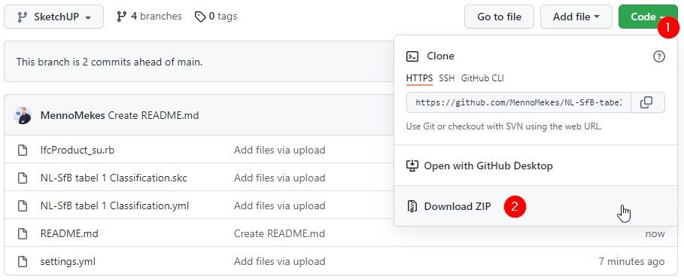

These files belong in three different places in the extension folders:

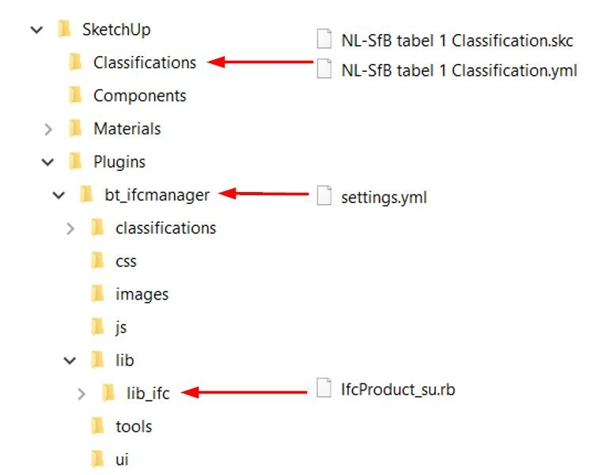

Go to: C:\Users\ ....... \AppData\Roaming\SketchUp\SketchUp 2021\SketchUp\Plugins\bt_ifcmanager. In this folder is the file 'settings.yml'. Replace it with the new one. In the \lib\lib_ifc folder, replace the "IfcProduct_su.rb" file. In the folder 'classifications' you put the other 2 files.

**Finally**

You've made it this far! Then you are definitely interested in unambiguous models. You can use and distribute the files freely. I'd love to.